BUENAVISTA WATER DISTRICT
OPERATIONS MANUAL
Updated April 2019

Table of Contents
Introduction 3
DEFINITION OF TERMS 4
GENERAL INFORMATION 5
Profile 5
VISION 5
MISSION 5
VALUE STATEMENT 5
SERVICE PLEDGE 6
THE BOARD OF DIRECTORS 6
PUMPING STATIONS 7
AREAS OF OPERATION 7
ORGANIZATION AND RESPONSIBILITIES 8
ORGANIZATIONAL STRUCTURE 9
DIVISION A - ADMINISTRATION & GENERAL SERVICES/ FINANCE & COMMERCIAL SECTION 10
DIVISION B - ENGINEERING AND CONSTRUCTION/ PRODUCTION AND WATER QUALITY 11
DUTIES AND RESPONSIBILITIES 13
OPERATING PROCEDURES 15
Commercial Services 15
A. New Service Connection 15
B. Payment of Water Bill 16
C. Reconnection of Disconnected Service Line 16
D. Request for Temporary Disconnection 17
E. Purchase of Materials 18
F. Meter Transfer 18
G. Complaints 19
H. Reading and Distribution of Water Bills 20
Administrative and Finance Services 21
A. Accounting Workflow 21
B. Disbursement Process 22
Procurement Process 23
A. Office Supplies: option if PS or not 23
B. Merchandise: 23
RECEIPT OF DELIVERIES OF INVENTORY 24
ISSUANCE OF OFFICE SUPPLIES 24
ISSUANCE OF NEW SERVICE CONNECTION MATERIALS 25
FEEDBACK FORM 26

Introduction

The Operations Manual of Buenavista Water District (BWD) contains the general information about the agency, its primary functions, mandates, operating procedures and organization.

The purpose of this manual is to present to its readers pertinent information about the district’s responsibilities and structure.

The manual is divided into three parts, as follows:

General Information – this section contains the company profile, such as the brief history of Buenavista Water District, mandates and functions, its missions and vision, service pledge, pumping stations and areas of operations.

Organization and Responsibilities – In this part of the manual, the organizational structure was shown using a diagram as of year 2019, as well as the duties and responsibilities of every section.

Operating Procedures – Contains the step-by-step procedures and work instructions of BWD. Activity flow charts are used to illustrate the different processes involved in daily operations.

DEFINITION OF TERMS

BWD – Buenavista Water District
PD – Presidential Decree

Category C – The categorization is a two-stage process. The initial stage is categorization based on the Number of Active Service Connections. For Category C a service connections of at least 3,000. The second stage of categorization considers the following factors: Gross Revenues, Total Assets, Net Income before Interest and Depreciation, and Staff Productivity Index. These factors will determine the Point-Rating Category Points 25-49 for Category C. Whichever is lower is the FINAL CATEGORY of the LWD.

SOA – Statement of Account
PPE – Property Plant and Equipment
PR – Purchase Requisition
LWUA – Local Water Utilities Administration
PhilGEPS – Philippine Government Electronic Procurement System
SALN – Statement of Assets, Liabilities, and Net Worth
SDs – Supporting Documents, such as Sales Invoice, Purchase Order, Job Order, Statement of Account

SACO – Service Application and Construction Order

SL – Subsidiary Ledger

GL – General Ledger

GENERAL INFORMATION

Profile
The Buenavista Water District (BWD) was created by virtue of Sangguniang Resolution No. 35-81 dated October 1, 1981 under the administration of Mayor Cayetano E. Amoroso, the Municipal Mayor of Buenavista. Conditional Certificate of Conformance (CCC) No.406 was issued to BWD by Local Utility Administration (LWUA) on July 5, 1989.

In October 26,1995, the Municipality of Buenavista passed Municipal Ordinance No. 05-95, otherwise known as the “Municipal Water System Act of 1995” and operated the Buenavista Water Supply System (BWSS) utilizing the old facilities of the defunct NAWASA with a partial rehabilitation cost approximately P2M.

In July 31, 1996, the Sangguniang Bayan of Buenavista passed Municipal Ordinance 6-96 which repealed Municipal Ordinance No. 05-95 and authorized the Local Chief of Buenavista to turnover the operation and facilities of the BWSS to BWD. The BWD had commenced its operation on the 24th of October 1996.

As of December 31, 2018, BWD has a total service connections of 6,377 with 5,761 active connections serving the population of 32119.

VISION

A partner in sustaining life and development of the community by providing safe, efficient and effective management of its water resources.

MISSION

We commit ourselves to the protection, development and sustainability of our water resources for a continuous delivery of safe and potable water for the community.

VALUE STATEMENT

Fearing God is Serving People with Humility before Honor.

SERVICE PLEDGE

We, the Board of Directors, Management and Staff and employees of Buenavista Water District- Agusan del Norte ( BWD), commit to:

Be always amiable and friendly to you our valued customers, serving you with efficiency, courtesy and promptness from Monday to Fridays (except on legal holidays) with no noon break.

Assure you that you have our best interest in mind when it comes to the delivery of safe, potable water through our constant treatment, maintenance and upgrading of our water system.

Satisfy your queries and complaints in a very professional and personalized manner, explaining clearly the requirements and policies pertaining to water installation, service connections, billing, and other necessary services for you to avail of water.

Provide you with a flow chart for your guidance in getting you serviced promptly.

THE BOARD OF DIRECTORS

Name |  | Position
Engr. Avelino B. Duglas |  | Chairman
Mrs. Florida A. Hordista |  | Vice-Chairman
Mrs. Laudita J. Arapan |  | Secretary
Dr. Merly P. Abiva |  | Member
Mrs. Heidi C. Boaquiña |  | Member

PUMPING STATIONS

Pumping Station | Implementation Year | Status
Pump Station No. 1 - Malpoc | 1981 | Un-operational
Pump Station No. 2 - Malpoc | 2002 | Stand-by
Pump Station No. 3 - Malpoc | 2003 | Operational
Pump Station No. 4 – Rizal | 2014 | Operational
Pump Station No. 5 – Rizal | 2018 | Operational

AREAS OF OPERATION

The jurisdiction OF BWD is the entire municipality of Buenavista. Out of the twenty five (25) Barangays, twenty two (22) Barangays are being served with 24/7 water service connection which comprised of the following:

Barangay 1

Barangay 2

Barangay 3

Barangay 4

Barangay 5

Barangay 6

Barangay 7

Barangay 8

Barangay 9

Barangay 10

Malpoc

Matabao

Manapa

Rizal

Sacol

Talo-ao

Agong-ong

Macalang

Alubijid

Malapong

Guinabsan

Abilan

ORGANIZATION AND RESPONSIBILITIES

BUENAVISTA WATER DISTRICT

BOARD OF DIRECTORS

DIR. AVELINO B. DUGLAS
Chairman

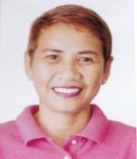

DIR. LAUDITA J. ARAPAN
Secretary

DIR. FLORIDA A. HORDISTA
Vice- chair

DIR. MERLY P. ABIVA
Member

DIR. HEIDI C. BOAQUIÑA
Member

ORGANIZATIONAL STRUCTURE
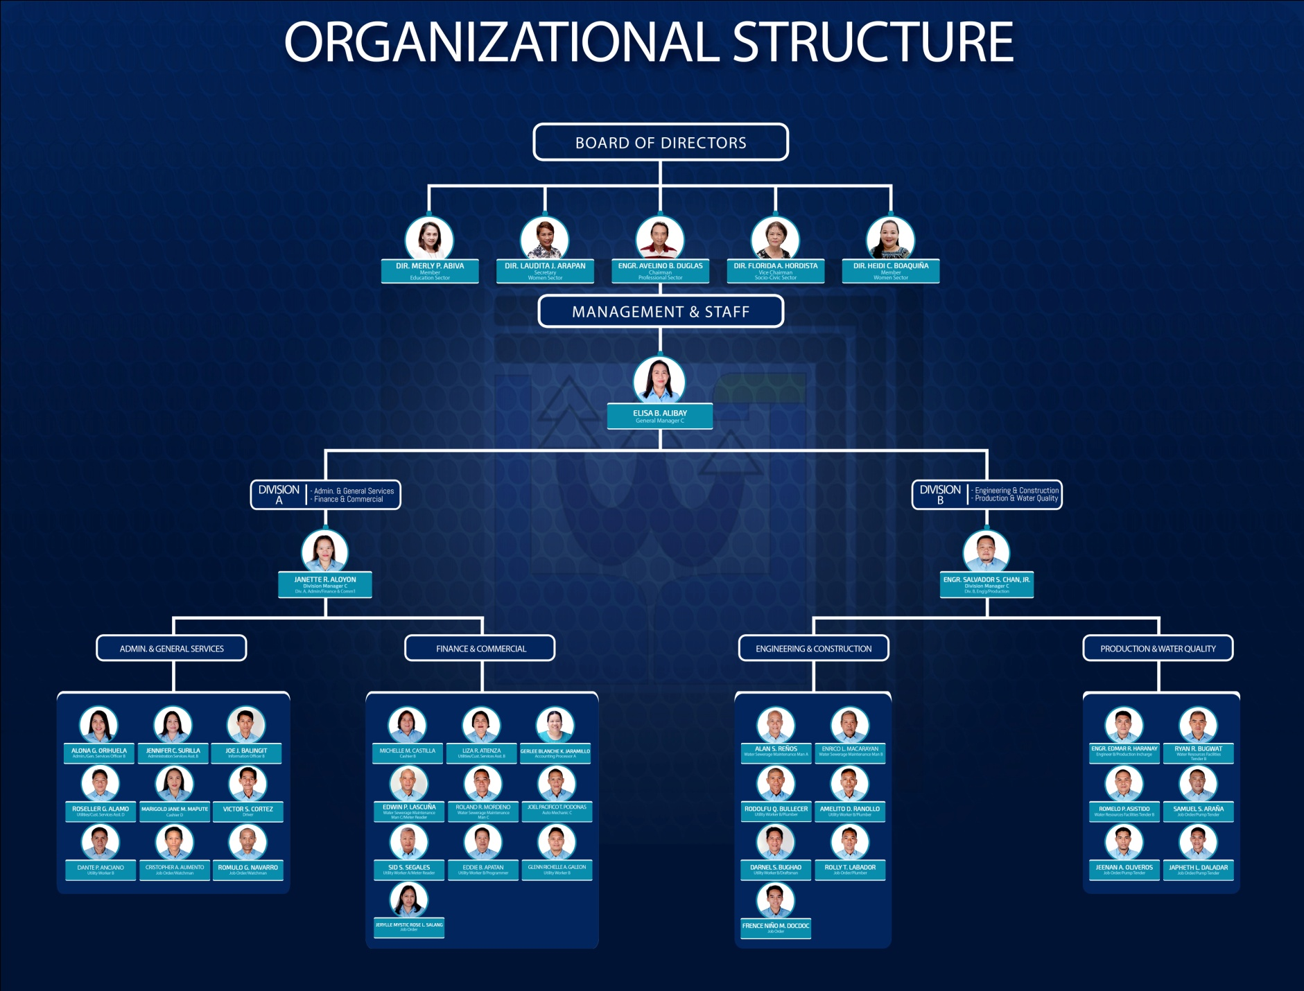

DIVISION A - ADMINISTRATION & GENERAL SERVICES/ FINANCE & COMMERCIAL SECTION

ELISA B. ALIBAY
General Manager C

JANETTE R. ALOYON
Division Manager C
Division A

Per

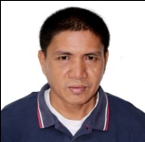
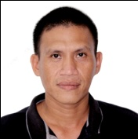
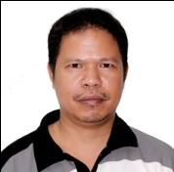
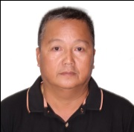
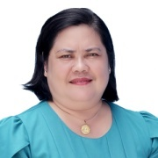
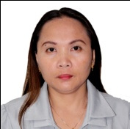
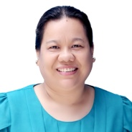
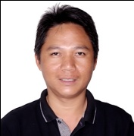
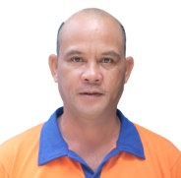
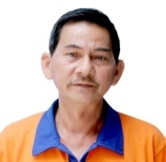
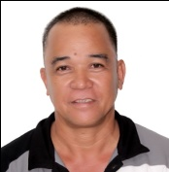

JOEL PACIFICO T. PODONAS
Auto Mechanic C

SID. S. SEGALES
Utility Worker A

EDDIE B. APATAN
Utility Worker B

MARIGOLD JANE M. MAPUTI
Cashier D

JENNIFER C. SURILLA
Admin. Services Assistant
B

GERLEE BLANCHE K. JARAMILLO
Accounting Processor A

Per

ROSELLER G. ALAMO
Utilities/
Customer Service Assistant D

EDWIN P. LASCUÑA
Water / Sewerage Maintenance Man C

VICTOR S. CORTEZ
Driver

ROLAND R. MORDENO
Water / Sewerage Maintenance Man C

ALONA G. ORIHUELA
Admin./
General
Services
Officer B

MICHELLE M. CASTILLA
Cashier B

JOE J. BALINGIT
Information Officer B

DANTE P. ANCIANO
Utility Worker B

GLENN RICHELLE A. GALEON
Utility Worker B

LIZA R. ATIENZA
Utilities/
Customer Service Assistant B

DIVISION B - ENGINEERING AND CONSTRUCTION/ PRODUCTION AND WATER QUALITY

ELISA B. ALIBAY
General Manager

ENGR. SALVADOR S. CHAN, JR.
Division Manager C
Division B

Per

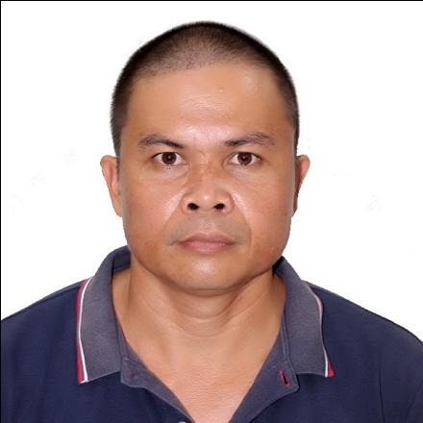
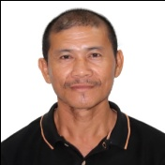
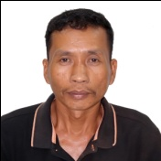
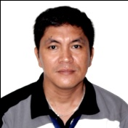
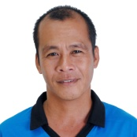
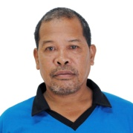
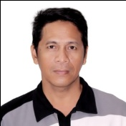

ROMELO A. ASISTIDO
Utility
Worker B

RODOLFO Q. BULLECER
Utility
Worker B

AMELITO D. RANOLLO
Utility
Worker B

DARNEL S. BUGHAO
Utility
Worker B

RYAN R. BUGWAT
Water Resource Facilities Tender B

Per

ENRICO L. MACARAYAN
Water Resource Facilities Tender B

ALAN S. REÑOS
Engineering Aide A

Per

ENGR. EDMAR R. HARANAY
Engineer B

DUTIES AND RESPONSIBILITIES

The Primary Functions

Board of Directors - is a policy making body. Ensures the availability of adequate financial resources and approves annual budget.

- Division A - Administration and General Services/ Finance and Commercial

Administration and General Services – Formulates and implements human resources programs, policies and procedures in accordance with the Civil Service rules and regulations.

Implements procedures on warehousing and maintenance of materials, supplies, vehicle and equipment in accordance with government rules and regulations, including procedures on procurement of adequate supply of materials, equipment and services.

Formulates and implements policies related to security measures of building, grounds and facilities.

Finance and Commercial- Prepares projected financial reports based on approved annual budget and determines financial resources available to carry out water district programs.

Implements procedures on cash management particularly on safekeeping, disbursement, and control of funds, collection of water bills and other income of the District.

Receives and processes service applications and attends to customer’s complaints and requests.

Enforces utility rules and regulations as to billings, delinquencies and adjustments. Maintains accurate and updated customers accounts.

- Division B - Engineering and Construction/ Production and Water Quality

Engineering and Construction – Plans and designs mainline extension, mainline improvements, and improvement of water district system and other pumping facilities.

Implements programs for extension, expansion, and improvement of water supply system.

Undertakes repair and maintenance of transmission and distribution of pipelines, installation and repair of service connection.
Production and Water Quality – Determines water production requirements and ensures the steady supply of water to the service areas.

Maintains water pumps and water treatment facilities. Monitors water system pressure, water level, and water quality in accordance with the standards set by the Philippines National Standard for Drinking Water and the World Health Organization.

Conducts preventive maintenance and repairs of equipment and pumping facilities. Initiates programs for protection and development of water resources.

The General Manager – The over-all in-charge of the management, operations and implementation of the programs and services.

Responsible for the Operation of the District and its long term and short plans.

Recommends to the BOD the organizational structure and manpower requirement, compensation and benefits schedule, water rates and charges, acquisition of real property, contracts for infrastructure projects.

Executes payment for approved projects and programs.

Conducts regular team managements meetings for upgrading, resolution-making and target-setting. This includes programs and projects under the Administrative & General Services Section, Finance and Commercial Services, and Operations/Technical Sections.

OPERATING PROCEDURES

Commercial Services

New Service Connection
A
Start

Print Computer Generated SACO
Engineering Section
Fill-out Summary of Expenses form, draw sketch, assign Account Number, issuance of charge slip and Print SACO
Admin/ Engineering
Attend Seminar
(every Wednesday at 2:00 PM)
Attendance Sheet

Billing Clerk
Confirm of Account number

B

Cashier B
Receives payment for Application Fee
In-house plumbing ready?
Customer
Contact Accredited Plumber for in-house plumbing installation
No

Accounting Section
Recommends Approval
Yes
Engineering Section
Conduct inspection of In-house plumbing
B

General Manager
Approved Application

In-house plumbing approved?
No

Engineering Section
Installation of New Service Connection Plumbers

Yes

Customer
Submit Proof of Ownership/ Authorization to Engineering Section/ Fill out Feedback Form
Proof of Ownership/ Authorization
End

Feedback Form

A

Payment of Water Bill
A
Start

Customer
Check OR if coincide with the Bill and count change
Water Bill
Customer
Present Water Bill to the Teller

Feedback Form
OR
Customer
Fill out Feedback Form
Teller
Accepts payment, issue Official Receipt

End
A

Reconnection of Disconnected Service Line
Start

Water meter pulled-out?
No
Yes
Customer
Proceed to Storekeeper to get charge slip for fittings
Charge Slip

Customer
Proceed to Teller and pay full amount of arrears

Customer
Proceed to Cashier to pay Reconnection Fee and Fittings (if any)

Discon. period 1 year?
Yes
Reconnection Request Form
Customer
Proceed to Billing Clerk and fill-out Reconnection Request

No
Customer
Attend Seminar / Orientation of New Applicants

A
Maintenance Order
Billing Clerk
Issues Maintenance Order

Customer
Fill out Feedback Form
Feedback Form
A

End
Commercial Section
Executes Maintenance Order of Reconnection

Request for Temporary Disconnection

Start

Customer
Proceed to Billing Clerk and request for Temporary Disconnection

Billing Clerk
Checks/ Verify unpaid balance

Customer
Proceed to Cashier to pay unpaid bill
Yes
Is there unpaid bill?

No
MO
Billing Clerk
Issue Maintenance Order for Disconnection
OR
Cashier B
Receives payment and issue Official Receipt

Customer
Fill out Feedback Form
Feedback Form

Commercial Section
Executes MO for Disconnection

Start

Purchase of Materials
– New Service, Maintenance
Start

Customer
Proceed to Storekeeper and present list of materials to be purchased
End
Customer
Present OR and claim purchase materials from Storekeeper

Storekeeper
Issue Charge Slip of Materials

Cashier
Receive payment for materials

Feedback Form
Customer
Fill out Feedback Form

Meter Transfer

A
Start
Request for Meter Transfer Form
Customer
Proceed to Billing Clerk to fill out Request for Meter Transfer Form
Engineering Section
Conducts inspection of actual location of meter to be transferred
Customer
Pay Meter Transfer Fee to the Cashier
Official Receipt
Cashier
Issues Official Receipt to Customer

MO
Billing Clerk
Prepare Maintenance Order (MO) and forward it to Engineering

Engineering Section
Execute MO for Meter Transfer

End

Customer
Proceed to Billing Section to Present OR and Fill our Feedback Form

Feedback Form
A

Complaints
Start

Customer
Go to the Public Assistance and Complaints Desk and Report complaint

Is the complaint about service line e?
^{Yes}
Service Request Form
Officer of the Day
Issue Service Request of complaint

^{No}
Engineering executes the Service Request
(Main/Secondary/Meter Leak Repairs, inspection for meter transfer)

Officer of the Day
Advice customer to proceed to Billing Clerk

End
Billing Clerk
Attend to the Customer’s Compliant/ Inquiry about Water Bill/ Account

^{No}
Water Bills not receive?
^{No}
Malfunction?
High / Zero consumption?
^{No}

^{Yes}
^{Yes}
^{Yes}

Billing Clerk
Issued Service Request to Commercial for inspection and Calibration of Water Meter
Billing Clerk
Issued Ledger as requested; Update Cellphone Number
Billing Clerk
Issued Service Request to Commercial for inspection

Customer
Fill out
Feedback form

Feedback Form

End

Reading and Distribution of Water Bills

Start

Billing Clerk
Prepares the Reading List for the Meter Reader

Meter reading
Conduct the reading within five (5) days and submit it to Billing Clerk

Billing Clerk
Encodes the reading and print the Water Bills submitted by the meter reader

Meter reading
Distributes the Water Bill to the Concessionaires on the after five (5) days reading cycle
Water Bills

End

Administrative and Finance Services

Accounting Workflow

Receipt and Collection Process

Receive Payment from Customer and Issue Official Receipt

Record Collection in Report of Collection and Deposit

Deposit Collections

Disbursement Process

Corporate Budget Specialist A
- Gathers supporting documents (SDs)
- Check completeness of the documents
- Prepare Budget Utilization Request (BUR)
- Prepare Disbursement Voucher (DV)
- Certifies funds availability

SDs, BUR and DV

Cashier B
Prepare and sign Checks
General Manager C
Approve Transaction

General Manager C
Approves Transaction & Counter sign Check

SDs, BUR, DV, Check

Corporate Budget Specialist A
- Updates and post to Journals
- Journalize transaction to Journal Entry Voucher (JEV)
- Post to General Ledger (GL) and corresponding Subsidiary Ledger (SL)

Cashier B
Issue Check to Claimant

Trial Balance Preparation

Procurement Process

Office Supplies: option if PS or not
^{No}
Purchase at PS-DBM?
Purchase Requisition (PR)
Request for Quotation (RFQ)

^{Yes}
Department of Budget and Management – Procurement Service

Justification
Purchase Order

Merchandise:
Purchase Requisition (PR)
Request for Quotation (RFQ)

Certified by: Corporate Budget Specialist A
Approved by: General Manager

Department of Budget and Management – Procurement Service
Posting for 7 days

Abstract of Quotations
Purchase Order ( PO)

Delivery within 7 days sss

RECEIPT OF DELIVERIES OF INVENTORY

Storekeeper updates Stock Card
Inspection and Acceptance Report

Delivery Receipt

Update Supply Ledger Card

ISSUANCE OF OFFICE SUPPLIES

PR
Stock Available?

Requisition and Issuance

Updates:
- Stock Card
-Report of Materials & Supplies Issues
-JEV - GL

ISSUANCE OF NEW SERVICE CONNECTION MATERIALS

Step 1: Step 2:

SACO
Completed
SACO

Storekeeper
-Prepare Requisition Issuance Slip (RIS); Gate Pass
- Prepare the materials needed
(Duration: 5 mins. for ordinary connection; 10 mins. for special)
Billing Clerk
- Encode New Service Connection data to Database

File

RIS

Gate Pass

Maintenance Crew
Receives the materials
(Duration: 5 minutes)

Completed
SACO

Storekeeper
-Record the issued materials to
Stock Card
- Turn-over of documents to Billing Section
(Duration: 5 minutes)

FEEDBACK FORM

Your feedback is important to us!
Help us improve our service by giving your suggestions. Kindly accomplish rating sheet at the back.
How we may contact you:
Name: _______________________________
Contact No.: _________________ Age: ____
Sex:_____ Occupation: __________________
Type of Concessionaire: ___________________
Date: ____________
Thank you for taking time to complete this form. If you have additional comments or suggestions please feel free to contact us through:
Call us at
(085) 343-4037
E-mail us at
bwd_adn@yahoo.com
BUENAVISTA WATER DISTRICT

Front

Rating Sheet Encircle the number that you feel is the appropriate answer to the question. | Excellent | Above Expectation | Just as Expected | Below Expectation | Very Poor | Not Applicable
How well were you treated? | 5 | 4 | 3 | 2 | 1 | 0
How pleasant is our facility?
Inside | 5 | 4 | 3 | 2 | 1 | 0
Outside | 5 | 4 | 3 | 2 | 1 | 0
How courteous is our staff?
Guard | 5 | 4 | 3 | 2 | 1 | 0
Storekeeper | 5 | 4 | 3 | 2 | 1 | 0
Plumbers | 5 | 4 | 3 | 2 | 1 | 0
Meter Readers | 5 | 4 | 3 | 2 | 1 | 0
Teller | 5 | 4 | 3 | 2 | 1 | 0
Complaints/New Accts Clerk | 5 | 4 | 3 | 2 | 1 | 0
Manager | 5 | 4 | 3 | 2 | 1 | 0
How fast was our service?
Tapping | 5 | 4 | 3 | 2 | 1 | 0
Repair | 5 | 4 | 3 | 2 | 1 | 0
Reconnection | 5 | 4 | 3 | 2 | 1 | 0
Meter Reading/Water Bill | 5 | 4 | 3 | 2 | 1 | 0
Distribution
Meter Transfer | 5 | 4 | 3 | 2 | 1 | 0
How well was your inquiry / problem / complaint attended? | 5 | 4 | 3 | 2 | 1 | 0
How is the quality of our water? | 5 | 4 | 3 | 2 | 1 | 0
How satisfied are you of our services | Satisfied |  |  | Dissatisfied
Given your experience service with us, please share your suggestions
that would help us enhance our services:
Back
-------------------------------------------------------------------------------
Prepared by:

ALONA G. ORIHUELA
Administration/ General Services Officer B
Noted by:

ELISA B. ALIBAY
General Manager C

